## **1. Convolutional Neural Network** (CNN)

**What is CNN?**

By now you already know what a neural network is. Neural networks have several other categories of networks, one of which is CNN. CNN processes (accepts) the images as tensors (2 or more dimensional).

**Why CNN?**

If we look at our previous learning units, in a normal neural networks (i.e. MLP), we flatten the image to a 1 D vector (we used a gray scale that has one channel, read on to learn about channels in next paras).

But what do we do when we have a colored image which has three channels of colors RGB (Stands for "Red Green Blue." RGB refers to three hues of light that can be mixed together to create different colors).

This is where CNN helps process images with more than 2 dimensions. Let’s take an example of cat image



It is a colored image with 3 channels (RGB) and it is dimensions are 64*64 pixels (you can simply get this for any image by clicking on the properties).

Here CNN helps you to process this 64 X 64 X 3 image without flattening it to a vector.

**CNN in action**

Remember the MNIST Dataset you’ve been working on? The below gif shows how every digit input goes through a CNN. You don’t need to understand the layers right now but just observe how the edges of each digit are recognised and processed. A fairly interesting concept!



## **2. Softmax:**

**What is softmax?**

Softmax is an activation function that turns the arbitrary values into probabilities.This activation function is often used for the output layer in case of multi-class classification problems. The outputs of this function are always in the range 0 to 1 and add up to 1.

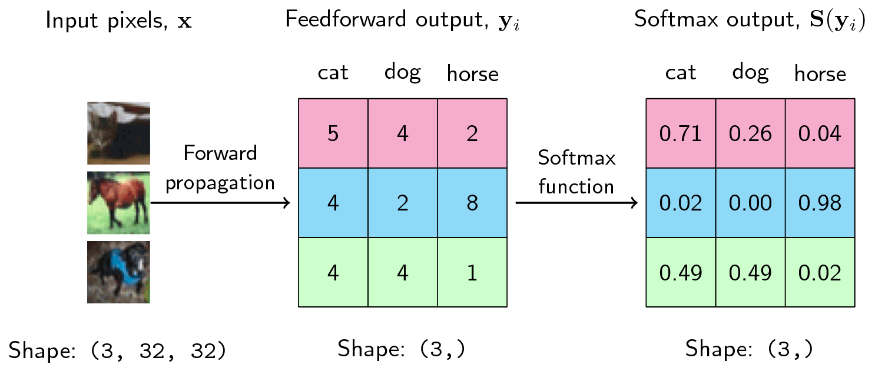

**Why softmax?**

In the case of multi-class problems, we want the output in such a way that it helps you to decide the final class of the given input. This can be easily achieved by comparing the probabilities of the given image falling in a particular class. Since the softmax returns the probabilities, the maximum probability tells that the input belongs to the given class.

## **3. Cross Entropy:**

* What is cross entropy? Cross entropy is a loss function that is used for classification problems.
* Why cross entropy? Cross entropy minimizes the distance between two probability distributions - predicted and actual.

And that’s it! This prep material is sufficient to get you through today’s session. We hope to see you there.